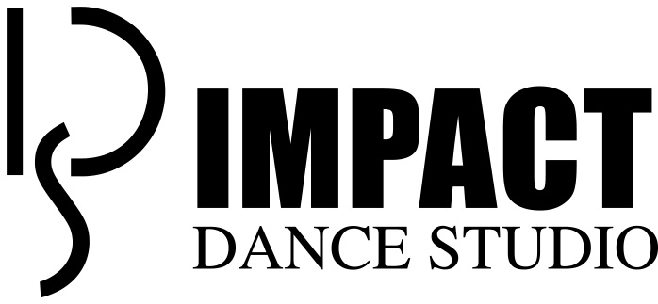
If your child is currently enrolled at Impact, you do not need to complete this form.

Child’s Name: _________________________________ Cell Phone: ___________________________

Parent’s name (print): ___________________________ Email: ______________________________

Mailing Address: ______________________________________________________________________

City: __________________________ State: ___________________ Zip: _____________________

Release of Liability
As the legal parent or guardian, I release and hold harmless Impact Dance Studio, Inc., its owners and operators from any and all liability, claims, demands, and causes of action whatsoever, arising out of or related to any loss, damage, or injury, including death, that may be sustained by the participant while in or upon the premises or any premises under the control and supervision of Impact Dance Studio, Inc., its owners and operators or in route to or from any of said premises.

Video & Photo Waiver
I give Impact Dance Studio, Inc. my permission for the public display of pictures and or video of my child for possible advertisement purposes (i.e. brochures, newspaper ads, web site, etc. - no names will be used).

I hereby agree to the above waiver.

___________________________________________ ________________
(Parent Signature) (Date)

If your child is currently enrolled at Impact, you do not need to complete this form.

Child’s Name: _________________________________ Cell Phone: ___________________________

Parent’s name (print):___________________________ Email: _______________________________

Mailing Address: ______________________________________________________________________

City: __________________________ State: ___________________ Zip: _____________________

Release of Liability
As the legal parent or guardian, I release and hold harmless Impact Dance Studio, Inc., its owners and operators from any and all liability, claims, demands, and causes of action whatsoever, arising out of or related to any loss, damage, or injury, including death, that may be sustained by the participant while in or upon the premises or any premises under the control and supervision of Impact Dance Studio, Inc., its owners and operators or in route to or from any of said premises.
Video & Photo Waiver
I give Impact Dance Studio, Inc. my permission for the public display of pictures and or video of my child for possible advertisement purposes (i.e. brochures, newspaper ads, web site, etc. - no names will be used).
I hereby agree to the above waiver.

___________________________________________ ________________
(Parent Signature) (Date)

